Ultimate Frisbee Study Guide
Terminology:

Pull – The long throw used to put the disc in play after a point is scored or start of
the game.

Marker – The player guarding the thrower.

Strip – When a defensive player causes an offensive player to drop the disc after
she/he has complete possession.

Stall – When a thrower fails to release the disc before the marker’s first utterance
of the word “3 Mississippi”.

Travel – When the thrower takes more than 3 steps.

Turnover- When the receiver drops the disc which results in which the opponents
get the Frisbee where it FIRST touched the ground.

Rules for Game Play:
- Players: A regulation game has seven players per team.

- To Start Play After a Score: After a point is scored, the scoring team lines up on the front side of the end zone line where they just scored at. They throw (“pulls”) the Frisbee to their opponents who are standing behind the midfield line.

- To Start the Game: The team that loses the rock, paper, scissors throws the “Pull” on the front side of the end zone line while their opponents who won the rock, paper, scissors stand behind the midfield line receiving the “Pull”.

- Scoring: Each time the offense completes a pass in the defense’s end zone, the offense scores one point.

- Movement of the Frisbee: The Frisbee may be advanced in any direction by completing a pass to a teammate. Players may not run with the Frisbee. The person with the Frisbee (“thrower”) has 3 Mississippi count to throw the Frisbee. The defender guarding the thrower (“marker”) counts out the stall count.

- Turnover (Change of Possession): When a pass is not completed (ex: out of bounds, drop, block, interception, and travel), the defense immediately takes possession of the Frisbee and becomes the offense.

- Non-Contact: No physical contact is allowed between players. The marker has to stand at least one arms length away from the thrower. A foul occurs when contact is made.

- Fouls: When a player initiates contact on another player a foul occurs. When a foul DOESN”T disrupt possession, the play resumes.

- Self-Refereeing: Players are responsible for their own foul and line calls. Players resolve their own disputes.

- Spirit of the Game: Ultimate Frisbee stresses sportsmanship and fair play. Competitive play is encouraged, but never at the expense of respect between players, adherence to the rules, and the basic joy of play.

Types of throw:
- Backhand: To throw the disc from the left side of the body for right handed players (or from the right for left hander players). The motion is similar in some respects to the backhand tennis.

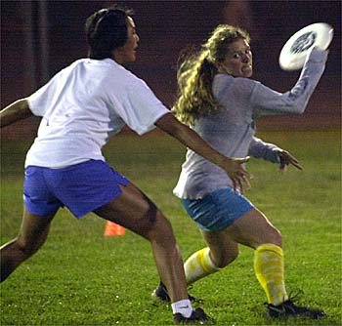

- Forehand: to throw the disc from the right side of the body for right handed players (or from the left for left hander players). The motion is similar in some respects to the forehand in tennis.

